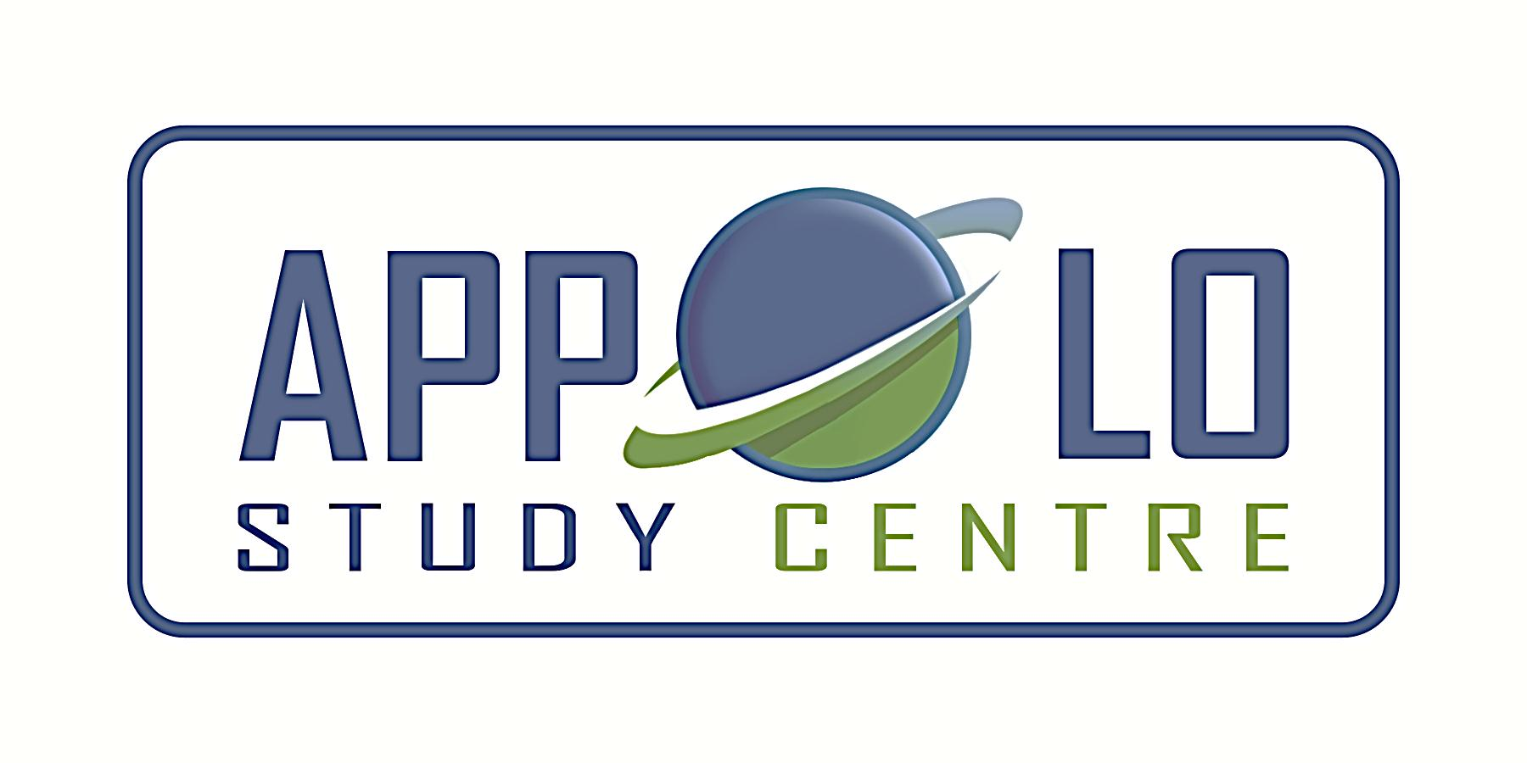
EVERYDAY CURRENT AFFAIRS–march 19, 2023
-

TAMIL NADU
- The State government - released three separate policies for Logistics, City Gas Distribution (CGD) and Ethanol Blending.

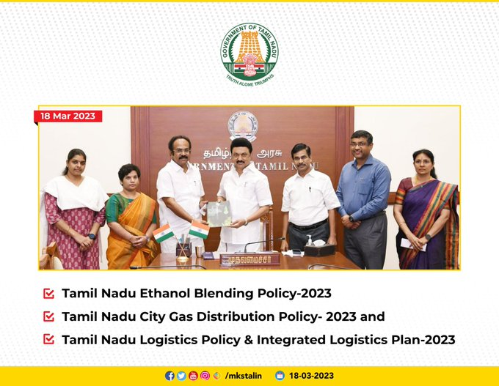

- Chief Minister MK Stalin released these policy documents in Secretariat on March 18

Tamil Nadu City Gas Distribution Policy 2023

- The City Gas Distribution (CGD) Policy 2023 aims to promote the adoption of natural gas by the State as a green and clean fuel.
- It lays the roadmap for expanding the gas network in the state to cover all districts and to speed up supply of piped natural gas to homes across the State
- The policy aims to attract investments worth Rs 35,000 crore and generate 20,000 jobs in direct and indirect categories
- This will result in the development of nearly 2.28 crore Piped Natural Gas (Domestic) connections and around 2,785 Compressed Natural Gas (CNG) stations covering all 38 districts within the next eight years.
  - In 2018, the Centre had given the first contracts to build city gas distribution (CGD) infrastructure, including for Chennai and neighbouring districts.
  - In Chennai and Tiruvallur, Torrent Gas Chennai Private Limited (TGCPL) will create infrastructure for 33 lakh domestic connections and 222 CNG retail outlets.
  - In Chengalpet and Kancheepuram, AG&P is supposed to create more than 1.15 lakh domestic connections.
  - The CGD network is being built in 15 districts and the contracts for the remaining 23 districts have also been authorized
  - Currently, just a few households in Nagapattinam district have piped natural gas connections.
- The policy aims at framing guidelines for state-run transport corporations to switch to CNG in order to reduce emissions and dependence on fossil fuels
  - It also encourages the possibilities of converting other vehicles such as cars, ambulances being utilised/engaged by the government departments.
- The policy envisages the creation of a state-level committee under the chairmanship of the chief secretary to facilitate the creation of CGD infrastructure and value-added services.
- The new policy could result in modifications to the Building Plan Rules to provide gas pipeline infrastructure in residential and commercial buildings at the architectural design stage.
- Tamil Nadu Industrial Development Corporation Ltd (TIDCO) will act as the nodal agency to expedite the implementation of petroleum & natural gas pipeline and CGD network projects.
- Apart from the state-level nodal agency, the policy named district collectors as district-level nodal officers.
- The policy aims to promote the usage of natural gas-based generators by all telecom operators, especially in urban areas, as an environment-friendly alternative at a lower cost.

Tamil Nadu Logistics Policy and Integrated Logistics Plan 2023

- The Tamil Nadu Logistics Policy and Integrated Logistics Plan 2023 was released by Chief Minister M K Stalin
- The state government released a logistics policy for the next five years, aimed at developing the logistics sector to support economic growth.
- The policy includes an integrated logistics plan for the next decade to align with emerging requirements and industry developments.
- It proposed to assess connectivity gaps in existing industrial clusters, agricultural aggregation/processing centres, fisheries/marine and animal husbandry clusters and prioritize development of road connectivity.
- The State logistics policy also proposes to set aside an appropriate land parcel in upcoming industrial parks/estates/clusters in the State for the development of truck terminals, preferably through private participation.
- It also plans to set aside land parcels (minimum 50 acres) at strategic locations in the state for development of multimodal logistic parks/logistic park/warehousing clusters/private freight terminal.
- Under the policy, identification of locations/clusters for development and strengthening of cold chain infrastructure has also been conceived.
- One of the key objectives of the policy is to reduce the environmental impact of the logistics sector by promoting a modal shift from road to eco-friendly rail and coastal shipping.
- The state government would also assess and identify pilot routes for development of dedicated high-capacity rail freight corridors in the state in coordination with the ministry of railways.
- To ensure coordination with logistics operators, service providers, and trade associations, the state will establish a Logistics Council.
  - The council will support data-driven decision-making and recommend initiatives for the progress of the logistics sector.
- Further, the state government announced special incentives and subsidies to units manufacturing technical textiles, man-made fibre (MMF) yarn from recycled products, MMF fabric and apparel manufacturing.
- This includes investment promotion subsidy, special capital subsidy, turnover-based subsidy and other subsidies
- The scheme was unveiled by chief minister M K Stalin on March 18
- The new scheme has extended the benefits on offer under the Tamil Nadu Industrial Policy 2021
- It covers both new projects or expansions in MMF fabric, MMF yarn from recycled materials and technical textiles and apparel with minimum investments of Rs.100 crore, Rs.50 crore and Rs.50 crore respectively
- Under the new scheme, manufacturing units can opt for either a special capital subsidy of 15% of EFA (eligible fixed assets) disbursed over 10 years or a turnover-based subsidy depending on the number of jobs created
- Apart from the investment subsidies, projects in these categories will also get training subsidy of Rs.4,000 to Rs.6,000 per worker per month for 6 months for residents of Tamil Nadu/ women, transgender employees, persons with disabilities or from SC/ST communities.
- The new scheme also proposes concessional land allotment in parks promoted by SIPCOT, electricity incentives, stamp duty incentives, green industry and quality certification incentives.
- Further, projects can also avail 5% rebate in the rate of interest on term loans taken for the purpose of financing the project, for a period of 6 years.

- On March 18, Chief Minister MK Stalin - announced the Ethanol Blending Policy (EBP) 2023
- The policy is aimed at promoting the state as a green economy and investment hub for cost-effective, alternative green fuel.
- The policy aims to attract investments worth Rs 5,000 crore in molasses and grain-based ethanol production in the state and achieve self-sufficiency in meeting the estimated ethanol blending requirement of 130 crore litres
- Ethanol is an agro-based product, mainly produced from a by-product of the sugar industry, namely molasses.
- The EBP is in line with the National Policy on Biofuels that targets an indicative 20% blending of ethanol in petrol by 2030 under the Ethanol Blended Petrol Programme.
  - The Centre’s Ethanol Blended Petrol Programme (EBP Programme) seeks to reduce pollution, conserve foreign exchange and increase value addition in the sugar industry, thereby enabling them to clear cane price arrears of farmers.
  - The Centre had launched the ethanol blended petrol (EBP) programme in 2003 with a target of supply of 5% ethanol blended petrol
  - It has now reset its target, to achieve 20% blending of ethanol in petrol by 2025 through the national biofuels policy.
- The policy also aims to mitigate climate change risks and reduce air pollution from fossil fuels.
- The policy seeks to support indigenous production of fuel grade ethanol under the EBP programme.
  - Currently, Tamil Nadu has installed a plant capacity of 664 kilo litres per day (KLPD) for producing fuel-grade ethanol under the EBP, with an additional 160 KLPD capacity in the pipeline.
- Currently, ethanol production in the state is primarily from sugarcane (molasses-based) distilleries.
- Under the policy, the state will encourage diversification of feedstock to encourage low water consuming and versatile crops like maize, sorghum and tapioca.
- Further, it will come up with appropriate guidelines to utilise damaged rice for ethanol production.
- The policy aims to improve farmer income through price realisation and expansion of opportunities due to ethanol blending, revive the sugar industry in Tamil Nadu through improved utilisation of existing mills, and enable capacity creation and diversification of grain-based distilleries.
- The policy applies to new grain-based distilleries or expansion of existing grain-based distilleries, new molasses and sugar/sugar syrup-based distilleries or expansion of existing distilleries (whether attached to sugar mills or standalone distilleries), and new dual feed distilleries or expansion of existing dual feed distilleries.
- The policy will be valid for a period of 5 years from the date of notification
- Tamil Nadu has 42 sugar mills with an overall cane-crushing capacity of 1.23 lakh tonnes per day
- However, the capacity utilization has remained below 60% over the past few years, with only 80 lakh tonnes crushed from 37 factories in the state during the last two decades.
INTERNATIONAL
- On March 17, Wyoming - became the first US state to ban the use of abortion pills, after the "Life is a Human Right Act" became state law
- Republican Governor Mark Gordon has signed the bill in which one would be charged if he/she prescribes, sell, or use “any drug for the purpose of procuring or performing an abortion”
- Under the "Life is a Human Right Act," which modifies an existing abortion ban in the state, prescribing or selling abortion medications is punishable by 5 years imprisonment and a fine of up to $20,000.
- Gordon also signed into law the "Prohibiting chemical abortions" bill, which makes the manufacturing, distribution, and sale of chemical abortion drugs punishable by up to six months imprisonment and a fine of up to $9,0000
- The bill would be effective from July 1.
INDIA AND NEIGHBOURS
- PM Narendra Modi and his Bangladeshi counterpart Sheikh Hasina - jointly inaugurated the Rs.377 crore India-Bangladesh Friendship Pipeline (IBFP) virtually on March 18

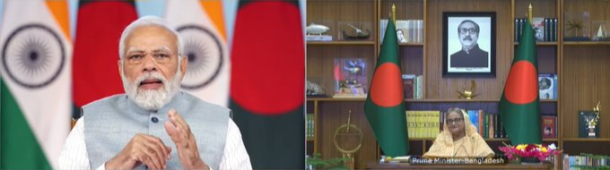

- Presently, diesel is supplied to Bangladesh through a 512km rail route.
- The 131.5km pipeline will supply up to 1 million tonnes per annum of diesel from Numaligarh in Assam to Bangladesh.
- This would not just help save on transportation costs but also reduce carbon footprint of moving the fuel, PM Modi said.
- IBFP is the first cross border energy pipeline between India and Bangladesh with a capacity to transport 1 million metric ton per annum (MMTPA) of high-speed diesel (HSD) to Bangladesh.
- It is also the only the second cross-border energy pipeline between India and its neighbours.
- The foundation stone for the construction of this pipeline was laid by both PMs in September 2018.
CONFERENCES & SUMMITS
- Prime Minister Narendra Modi - inaugurated the Global Millets (Shree Anna) Conference at the Indian Agricultural Research Institute campus in Pusa, New Delhi on March 18

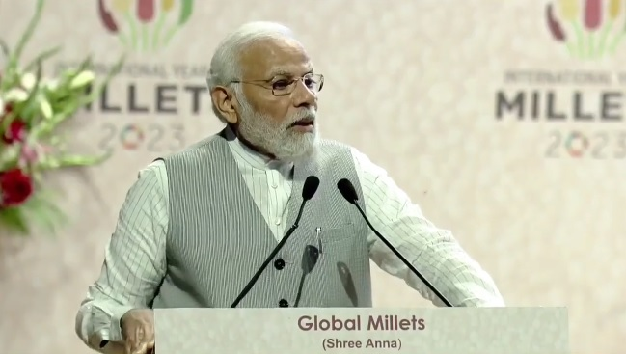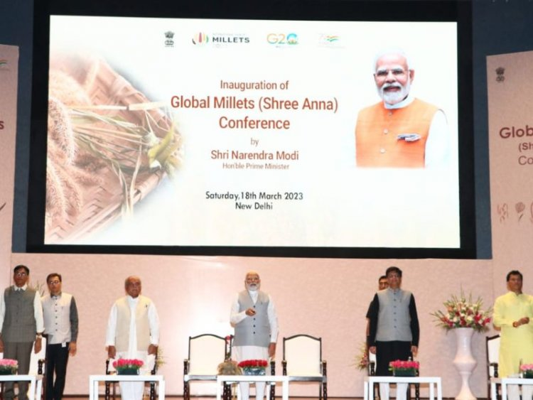

- The conference is being organized by the Ministry of Agriculture & Farmers Welfare
- During the event, Prime Minister digitally launched a compendium of Indian Millet (Shri Anna) startups and a book of millet (Shri Anna) standards.
- He also unveiled a Commemorative Stamp and Commemorative Coin of the International Year of Millets 2023
- The Prime Minister informed the foreign delegates about India’s branding initiatives for millets as India now calls millets - Shree Anna.
- Prime Minister also noted that millets were declared nutri-cereals in 2018 and primarily cultivated in 12-13 different states in the country
- The two-day global conference will have sessions on all important issues related to millets (Shree Anna) like promotion and awareness of millets among producers, consumers and other stakeholders; millets’ value chain development; health and nutritional aspects of millets; market linkages; research and development etc.
- Based on India's proposal, the year 2023 was declared the International Year of Millets (IYM) by the United Nations General Assembly (UNGA).
- The conference will be attended by Agriculture Ministers of various countries, international scientists, nutritionists, health experts, start-up leaders and other stakeholders.
- The Embassy of India will be organising events in Bulgaria throughout the year to promote use of millets as a nutritious food.
- India has been traditionally the largest producer of millet in the world and accounts for 20 % of global production.
- Millets are capable of growing under drought conditions, under non-irrigated conditions even in very low rainfall regimes.
- Some of the common millets available in India are Ragi (Finger millet), Jowar (Sorghum), Sama (Little millet), Bajra (Pearl millet), and Variga (Proso millet).
- Millets are cultivated in more than 130 countries around the world and are the traditional food for over 600 million people in Asia and Africa.

- Union home and cooperation minister Amit Shah – delivered the concluding address in the 49th Dairy Industry Conference held at Gandhinagar, Gujarat on March 18

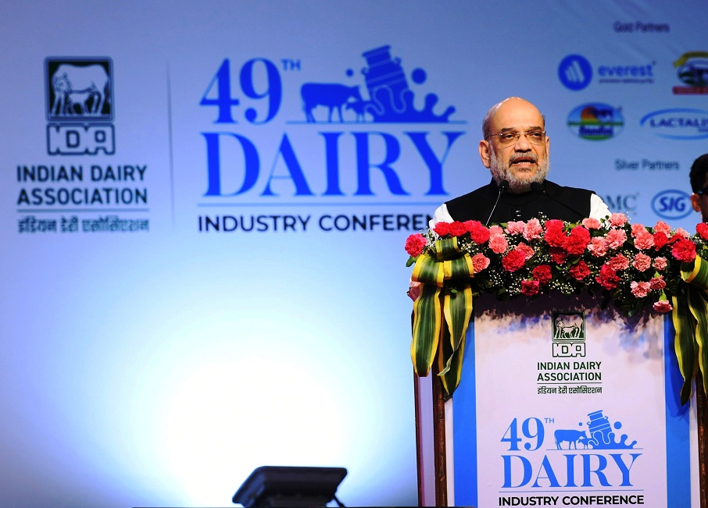

- The conference was earlier inaugurated by Union Minister of Fisheries, Animal Husbandry and Dairying, Parshottam Rupala on March 16
- It was organized by the Indian Dairy Association (IDA), an apex body of the dairy industry in the country
- During the concluding speech, Union Home Minister Amit Shah said that India will be contributing 33% of the world’s total milk production by 2033-34 after new village-level dairy societies are set up
- He added that by 2033-34, India’s milk production will reach 330 million metric tonnes per annum.
- The conference was organized on the theme ‘India dairy to the world: Opportunities & Challenges’.
- The conference witnessed interactions between dairy professionals, experts from overseas and India, milk producers, dairy cooperatives, scientists, government officials, policymakers, academicians, and other stakeholders
- The three-day conference and exhibition showcased the latest technologies in milk production, processing, storage, and packaging solutions.
- Further, awards were given to individuals and organizations for their contribution to the growth of the dairy industry.
- Due to the Covid-19 pandemic, the conference is being held after a gap of three years in collaboration with its Gujarat State chapter.
- Gujarat accounts for 30% of the country’s total milk procurement
DEFENCE
- The second edition of Africa-India Field Training Exercise, AFINDEX-2023 - will be held from March 21-30 in Pune.



- Army Chief’s and representatives of Chief’s from 21 African countries will be attending the event and 24 African militaries are being represented by their contingents or teams of observers
- The countries which are sending their personnel are Ethiopia (5), Ghana (10), Kenya (5), Lesotho (10), Niger (12), Seychelles (10), Tanzania (6), Uganda (10), and Zambia (10)
- Eleven other countries, including Congo, Egypt, Nigeria, Rwanda, Zimbabwe, Cameroon and Morocco, are sending observers for the exercise
- The second edition of AFINDEX will enable the participating contingents to hone their tactical skills, drills and procedures in joint operations for peacekeeping under United Nations mandate.
- The exercise will also create synergy and better understanding with armies of African nations and promote Indian defence industries.
- The 10-day long exercise will commence with an opening ceremony at Foreign Training Node, Aundh, Pune.
- A comprehensive validation exercise on the theme “Humanitarian Mine Actions and Peace Keeping Operations” under the UN mandate is also scheduled.
- The Joint exercise will promote the idea of “Africa-India Militaries for Regional Unity (AMRUT)” and will focus on incorporating the current dynamics of UN peacekeeping operations (UNPKF) through practical and comprehensive discussions and tactical exercise.
- The validation exercise will be conducted on March 29 and it will be witnessed by the chiefs of the African armies.
- The first AFINDEX was held in Pune in March 2019 which saw the participation of 20 African nations.
- Apart from the AFINDEX, the India-Africa Chiefs Conclave will also be held in Pune on March 28.
- The conclave will include talks by renowned speakers on the issue of India-Africa Defence partnership and India Defence Industry potential and contribution towards regional security.
- Defence Minister Rajnath Singh will be the chief guest in the event.
- The India-Africa Chiefs Conclave will take place over two sessions.
  - The first session will explore the key pillars of the India-Africa defence partnership while the second session will focus on the Indian defence industry's Outreach to Africa
- Visit and interaction with various Defence production Industries and African representatives is also planned during the conclave.
- The broad theme of the dialogue is ‘India-Africa: Adopting Strategy for Synergising and Strengthening Defence and Security Cooperation’.
- The army chiefs of Congo, Niger, Zambia, Zimbabwe, Malawi, Uganda, Seychelles, Gambia, Tanzania and Kenya are attending the conclave
- Additionally, the Army Design Bureau (ADB), Indian Army and FICCI will jointly organize an 'Equipment Display' on March 29 - 30, at Aundh Military Station, Pune.
- The event will showcase Indian defence industry capability and enable exports to these friendly nations opportunities.
- In 2020, it has to be recalled that the India-Africa Defence Ministers Conclave was held on the sidelines of the DEFEXPO in Lucknow
SPORTS
- ATK Mohun Bagan - won their inaugural Indian Super League (ISL) title at the Fatorda stadium in Goa on March 18



- In the final game, ATK Mohun Bagan have defeated Bengaluru FC on penalties (4-3), after the game ended 2-2 after extra time
- Mohun Bagan entered the ISL as ATK Mohun Bagan after a merger with ATK in the 2020-21 season.
- This is the first ISL title for the ATK Mohun Bagan (ATKMB) after the merger, with ATK and Atletico de Kolkata winning three titles together.
- After the game, franchise’s owner Sanjiv Goenka announced that the club would be known as ‘Mohun Bagan Super Giants’ going forward.
- As the winners, ATKMB took home a prize money Rs. 6 crore, while runners-up Bengaluru FC were awarded Rs. 2.5 crore.


