k.karthika 6380810285
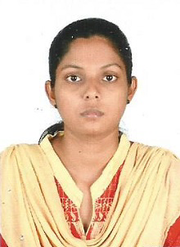
Objectives

To work in a good environment for the enhancement of my abilities and optimum profitability of the organization.

Academic qualifications

Qualification | Institution | Year of passing
X | Seventh Day Matriculation Higher Secondary School, Virudhunagar. | 2011
XII | Seventh Day Matriculation Higher Secondary School, Virudhunagar | 2013
B.Sc. (Physics) | V.V.Vanniaperumal College for Women, Virudhunagar. | 2016
M.Sc.(Physics) | Madura College, Madurai. | 2018

Technical Skills:

Type writing in both English and Tamil
(Senior grade)

Skills

- Good in communication
- Good in content making
- Good in English language
- Good knowledge in Word press
- Attended TNPSC Group 2 mains exam twice

Personal details

Name K. Karthika

Qualification M.Sc. Physics

Age/ DOB 27Years || 05/12/1995

Gender Female

Marital status Unmarried

Nationality Indian

Religion Hindu

Caste Sc

Address 6/1009/9C Karupaswamy Nagar,
Near New Railway Colony,
Virudhunagar.

Phone No 6380810285

Email karthikak51295@gmail.com

