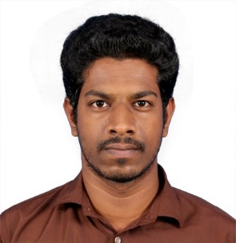

VASANTHAN G
11 Edaiyanchavady road
Lawspet (Po), Karuvadikuppam
Puducherry, 605 008

Contact Number: +91-9965704926, 0413-2239100
E-Mail: vasanthmec26@gmail.com or vasantheee.pec@gmail.com
CAREER OBJECTIVES

To succeed in an environment of growth and excellence and earn a job which provides me job satisfaction and self development to help me achieve personal as well as organizational goals.
EXPERIENCE

- 1 Year of teaching experience in Sri Aravindar Engineering College as Assistant Professor in Dept of EEE, Sedarapet 2017-18
- Worked as Soft Skill Trainer in Indian Skills Foundation, Puducherry for 6 months

ACADEMIC DEATAILS
- M. Tech Electrical and Electronics Engineering (EDC)
Name of College : Pondicherry Engineering College, Puducherry
University : Pondicherry University
Year : 2015-2017
Mark : 6.58 CGPA

- BE Electrical and Electronics Engineering
Name of College : Mailam Engineering College, Mailam
University : Anna University
Year : 2011-2015
Mark :7.71 CGPA

.

- Higher Secondary School Leaving Certificate
Name of School : Vivekanandha Higher Secondary School, Puducherry
Board : Board of Tamil Nadu
Year : 2010 - 2011
Mark : 68.16%

- Secondary School Leaving Certificate
Name of School : Vivekanandha Higher Secondary School, Puducherry
Board : State Board – Tamil Nadu
Year : 2009
Mark : 90.4%

GOVERNMENT EXAMS ATTEMPT

- SSC (CHSL) – 2 Attempts
- TNPSC Group 1,2, 2A, 4, VAO, TNUSRB (SI, PC)
- TNFUSRC (Forester, Forest Watcher, Forest Guard) – 2 Attempts

COMPUTER PROFICIENCY

- Diploma in Computer Applications
- Computer on Office Automation
- Typing both English & Tamil Completed (Lower & Higher)

PERSONAL STRENGTHS

- Easily mingle with others.
- Willingness to learn new things.
- Good leadership quality, adaptable and focus on work.
- Punctual.
- To innovate many things for real time applications.
PERSONALDETAILS

- Date of Birth : 26/12/1993
- Gender : Male
- Marital Status : Unmarried
- Nationality : Indian
- Religion : Hindu
- Languages Known : English, Tamil, French (Read)
DECLARATION

I hereby declare that the information furnished above is true and correct to the best of my knowledge and belief.

Date : 28.04.2023 G. VASANTHAN
Place: Puducherry

