KOUSHIK SRINIVAS V 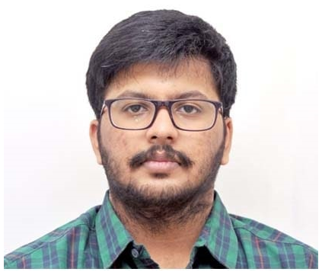
Phone: +918778377085
E-mail: vjkoush1997@gmail.com

Education:

Qualification | Year | Institution | Percentage
B.Tech-Electronics and Communication Engineering | 2014-2018 | SASTRA University, Thanjavur | CGPA-7.25/10
Tamil Nadu State Board Higher Secondary Education  12th Standard | 2014 | Sri Ramana Vidyalaya Montessori Matriculation Higher Secondary School, Rajapalayam. | 96.58%
Tamil Nadu State Board High School Education  10th Standard | 2012 | Sri Rao Bahadur A.K.D.D Boys’ High School, Rajapalayam. | 96.8%

Strengths:
- Communication skills
- Vocabulary
- Eagerness to explore
- Ability to learn things quicker
- Ability to complete a project at stipulated time period
- Aptitude
- Cognitive skills

Experience in Competitive Examinations field:
- Preparing for Civil Services exams since 2018-19
- Cleared TNPSC Group 1 Preliminary Examination 2020
- Cleared SBI Clerical Exam, 2019

Work Experience:
- Currently working in Veranda Race Institute since October 2021
- Designation: SME (Subject Matter Expert)

Personal Details:
Father’s Name: V.Venkata Subramanian
Address: 102/292, Muhilvannam Pillai Street,
Rajapalayam-626117,
Virudhunagar District,
Tamil Nadu.

Date of Birth: 20th April 1997

Languages Known: Tamil, English, Hindi (Read and Write)

